Name: - Tanishq Parab

Roll No: -A033

TYBSC IT

Linux Administration Practical

Practical 1

Installation of RHEL 6.X

* New Virtual Machine Wizard pop-up appears, click NEXT.

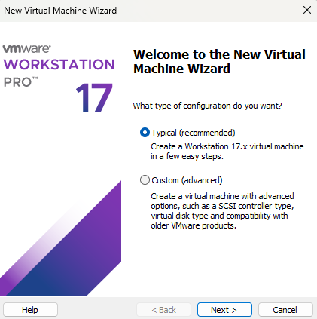

* + Select I will install the operating system later and click NEXT.

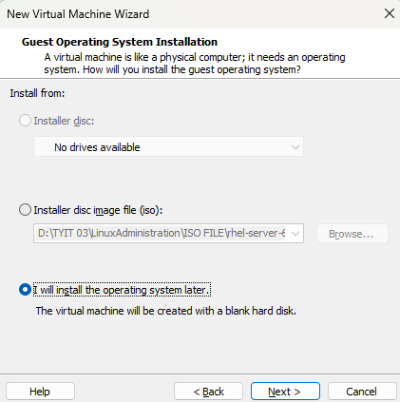

* + Click NEXT again

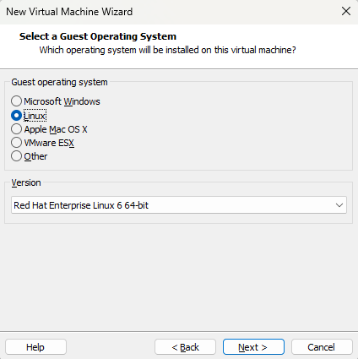

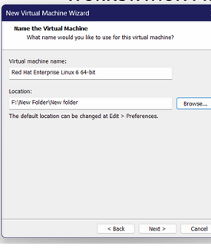

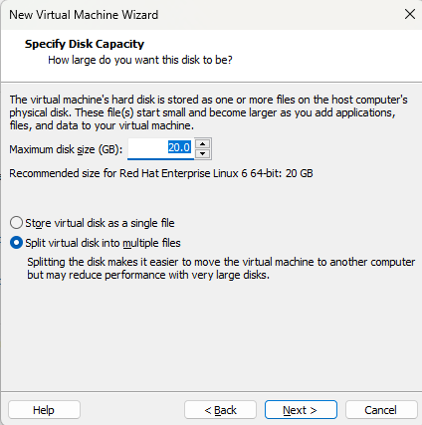

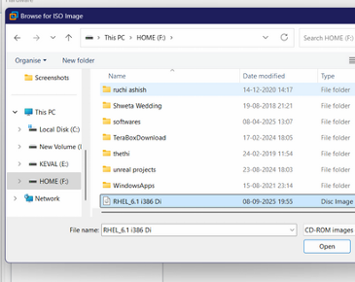

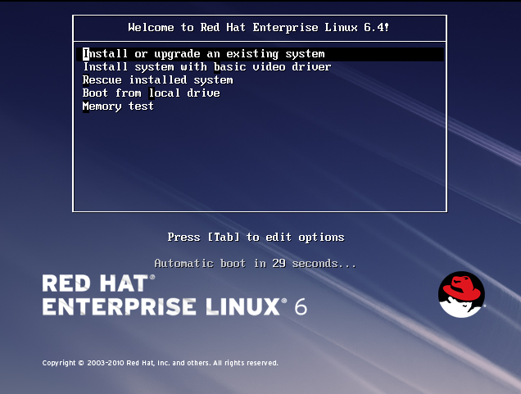

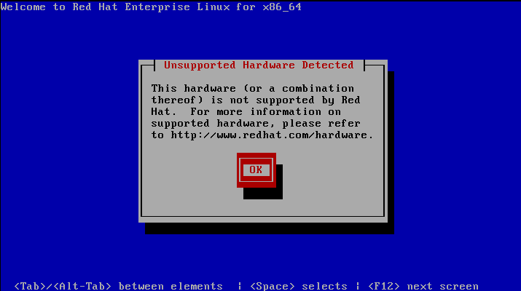

* + - Click **NEXT**



* + - Default language selected is English and click NEXT.

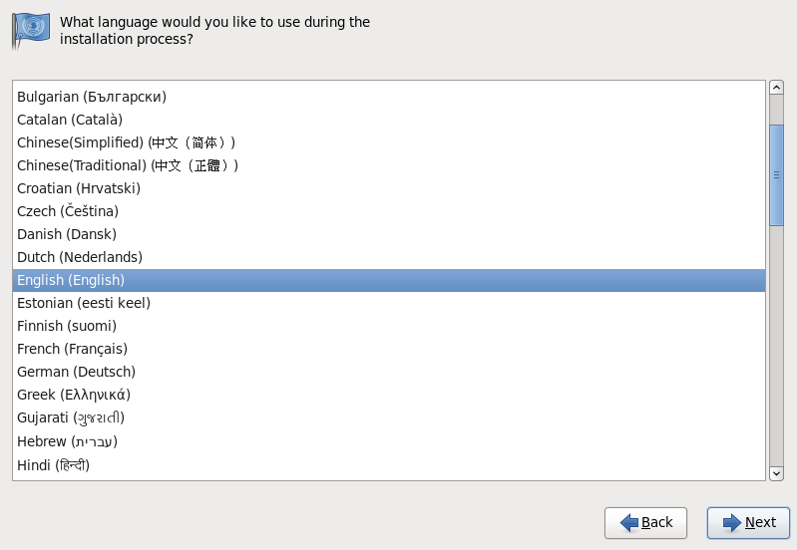

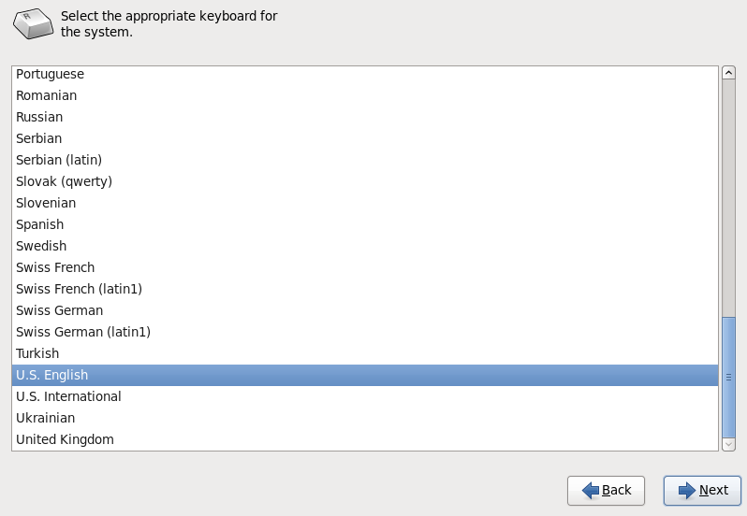

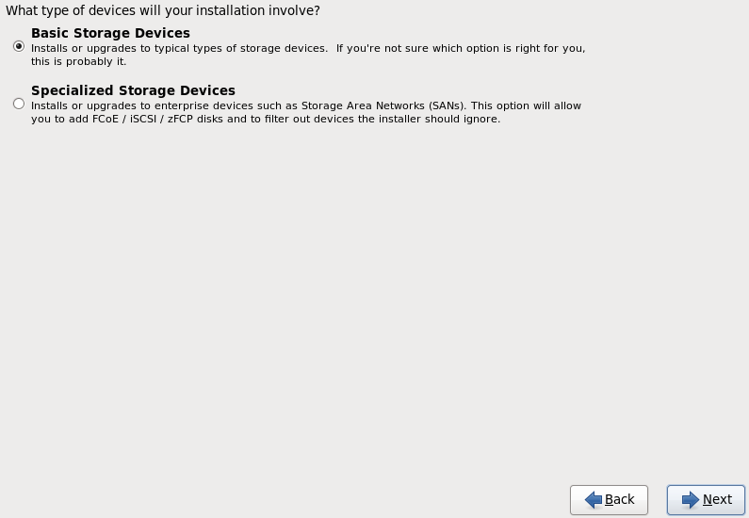

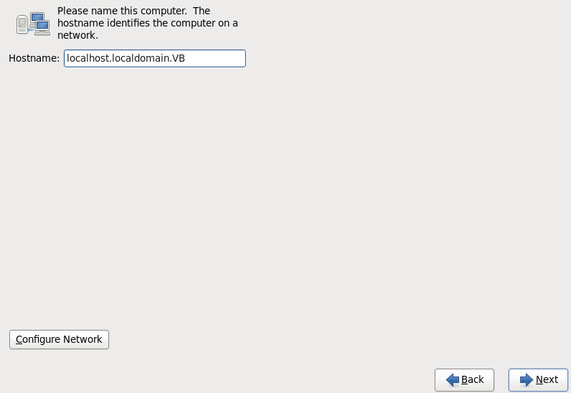

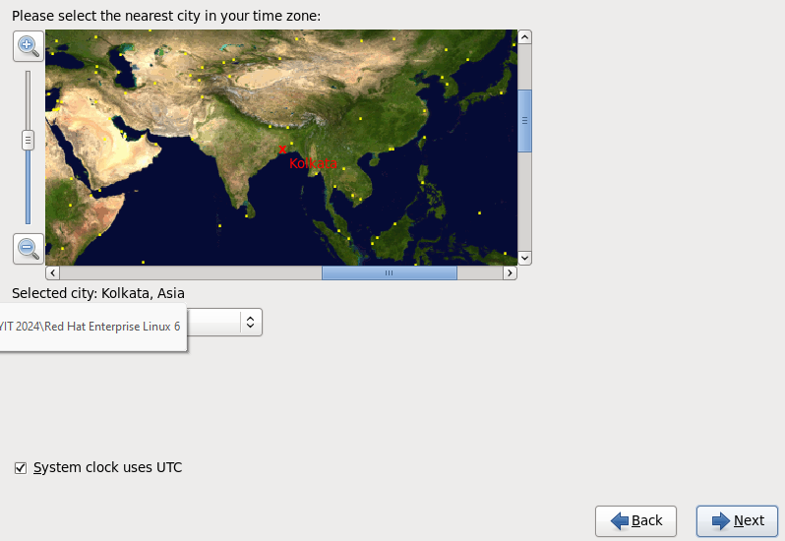

* + Set the password for root user.

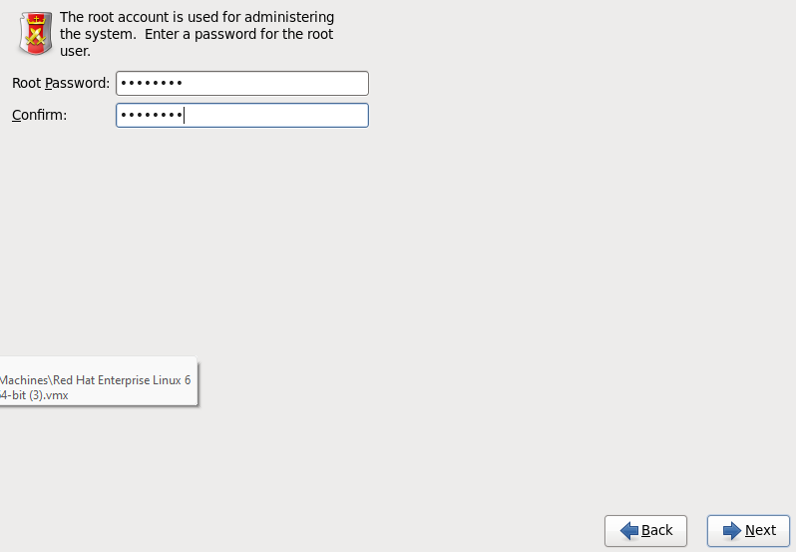

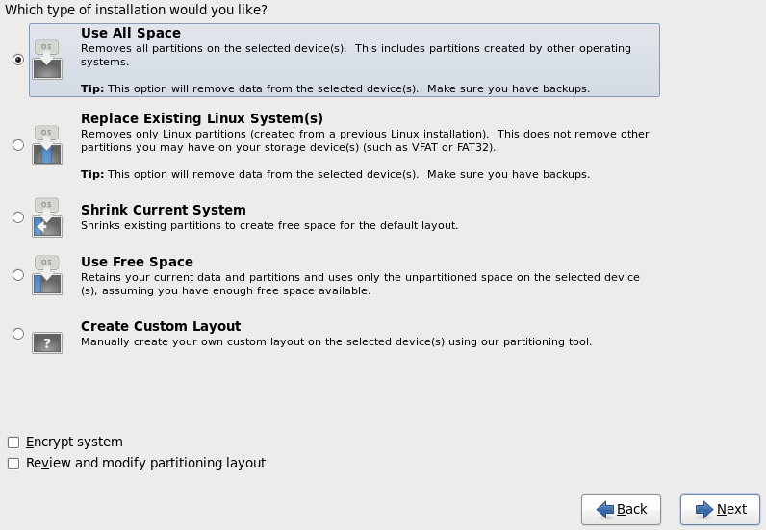

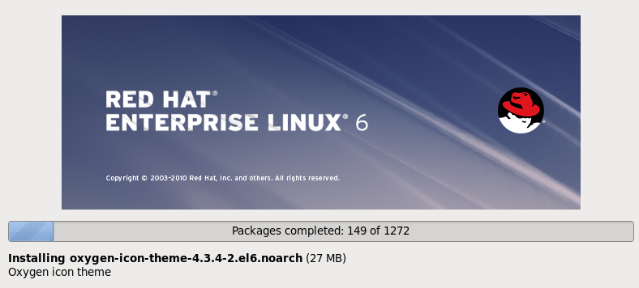

Practical 2

Graphical User Interface and Command Line Interface and Processes

1. Exploring the Graphical Desktop

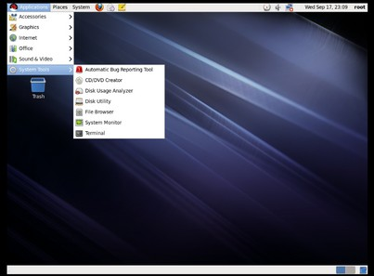

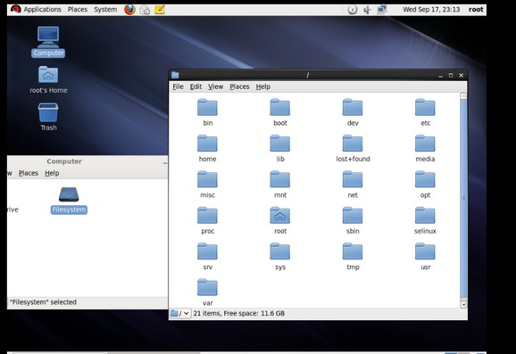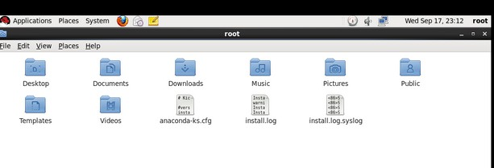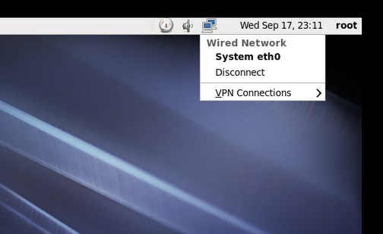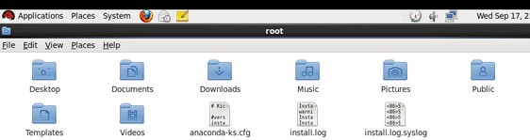

2) b. The Command Line Interface

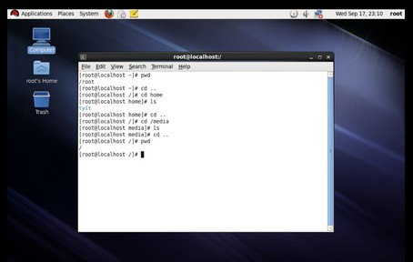

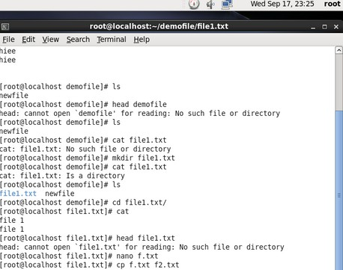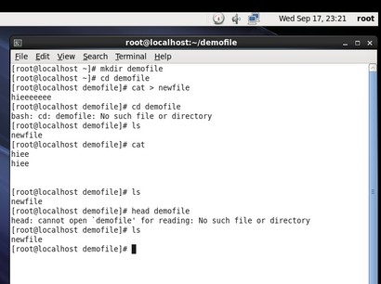

2) c. Managing Processes

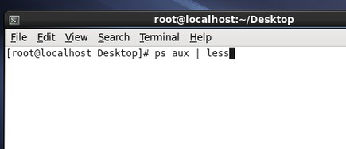

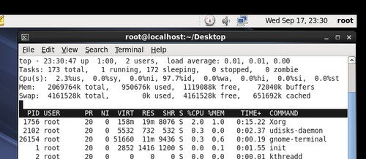

Practical 3

Working with Users, Groups, and Permissions

Users & Groups:

1. Create a user information with a home directory and a user id 1286

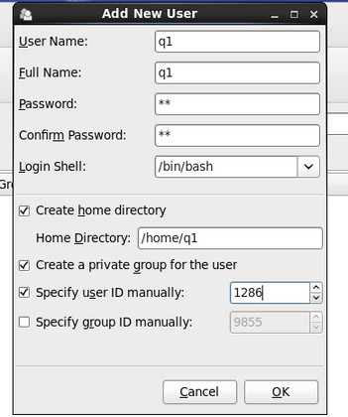

1. create a user tech with a user id 9846 and group id 1689

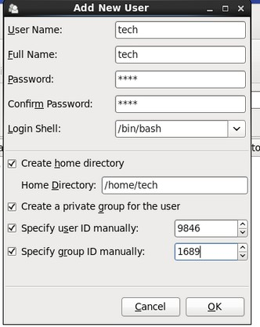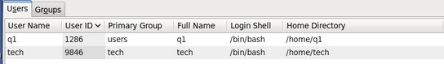

3)remove tyit1 user from project group



 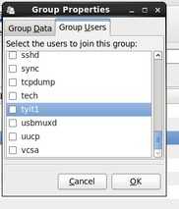

4)add username tyit using user add command

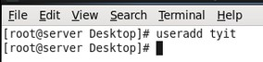

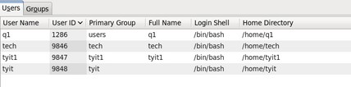

Create a password using passwd command

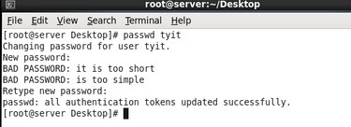

* + - 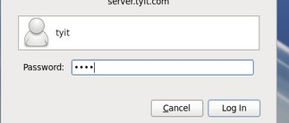Login using this user



1. examine home directory of each user

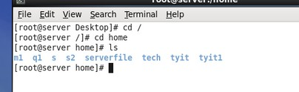

1. examine /etc/shadow, /etc/group,/etc/passwd

With respect to new addition

1. Create 2 groups manager and staff add user to the group
2. login using root account with del command.
3. delete any tow users using various options of userdel command

Permissions:

created a main directory

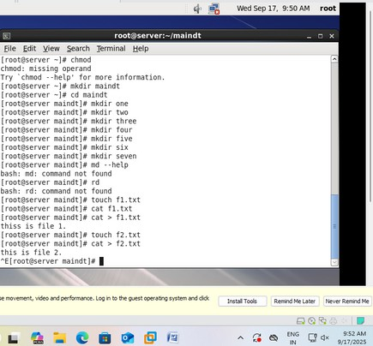 create 7 subdirectories and 2 files in the main directory change permissions.

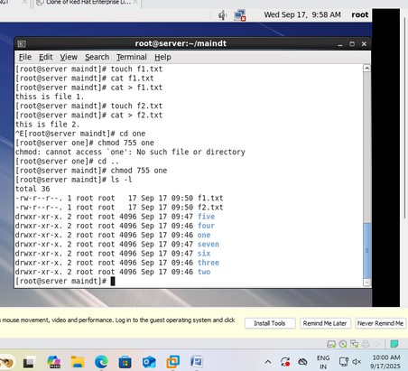

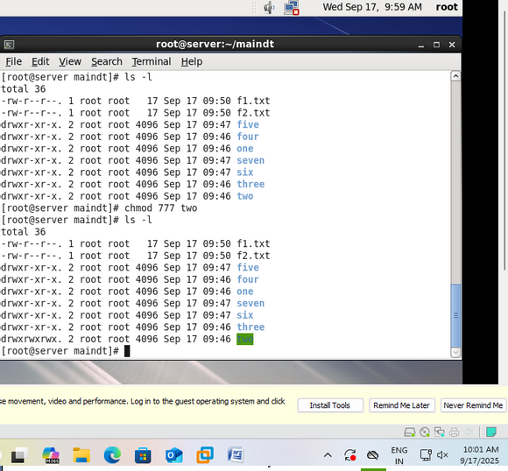

|  |
| --- |
| Practical 4  Working with RPM Storage and Networking  4) a Using Query Options |
| 4) b Extracting Files From RPMs |

|  |
| --- |
| 4) c Configuring and Managing Storage |
| 4) d Connecting to the Network |

Practical 5

|  |
| --- |
| Practical 6  DNS, DHCP and Mail Server Configuring DNS  Go to main -> terminal Gedit /etc/hosts  Add after 2 line – 192.168.1.3 srver.tyit.com  Save  Gedit /etc/sysconfig/network-scripts/ifcfg.eth0 File open  Gedit /etc/sysconfig/networl Localhost domain –delete Write- server.tyit.com  Save  Gedit /etc/resolv.conf  Add NAMESERVER 192.168.1.3  Save  Cd /etc  Service network restart ok ok  If not then click on network manager to turn it on then try  Now, cd ..  Cd media/RHEL…./Packages  Now, |

|  |
| --- |
| Rpm –ivh bind*  Install  Gedit /etc/named.conf empty Install now properly  Ls bind* Now,  Rpm –vh bind-9.7.3-2.e16.i686.rpm Gedit /etc/named.conf  File will open Options……? Cd etc  Ls named*  Gedit /etc/named.rfc192.zones  Copy one zone “ “ in {….}  Than change name as zone ……? And file reversed.zone  Cd .. (go to root) Cd /var/named Ls  Cp named.localhost Forward.zone Cp named.loopback reversed.zone Gedit forwar.zone  IN SOA server.tyit.com root.server.tyit.com { …}  IN NS server.tyit.com SERVER IN A 1912.168.1.3  Gedit reversed.zone  IN SOA server.tyit.com root.server.tyit.com  IN NS sever.tyit.com IN PTR server.tyit.com  Chgrp named forward.zoe Ls –l  Chgrp named reversed.zone  Ls –l  Service named start Dig server.tyit.com  If timed out the turn on the network manager(systemeth0) The try it again  Requirmentd gor configuration DNS  Bind package create forward & reversed file |

|  |
| --- |
|  |

|  |
| --- |
|  |

|  |
| --- |
| 6) a Configuring DNS |

|  |
| --- |
|  |

|  |
| --- |
|  |

|  |
| --- |
|  |

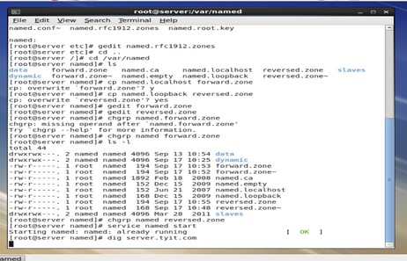

6) b Configuring DHCP

Ifconfig

For editing – go to network manager.(two pc) Right click , wired ->system eth0 than edit

Click on manual -> near table ->click add-> put address 192.168.1.3 Net mask – 255.255.255.0

Dns sever – 192.168.1.3 Gateway- 192.168.1.0

Ifconfig

If ip add has changed to 192…. It is correct If no than type = service network restart. rpm –qa | grep dhcp

ls

gedit /etc/dhcp/dhcpd.conf close opend file.

Cp /usr/share/doc/dhcp-4.1.1/dhcpd.conf.sample /etc/dhcp/dhcpd.conf

Overwrite? Yes

gedit /etc/dhcp/dhcpd.conf

go to line subnet 255.255.255.0

(below this is very basic subnet declaration) Change it to

Service dhcp start Service dhcp restart Chkconfig dhcpd on Chkconfig –list dhcpd Dhcp 6:off 1:off 2:on

Dhcp server is setup now machine is ready Close power off

Right click -> manage ->clone ->click->next

Current stare create linked clone 0 first ->next ->clone of red.hat linux

Close

Now clone machine will start

Open og linux machine as root -> systemeth0->edit->manual->apply Gedit /etc/sysconfig/network-scripts/ifcfg-eth0

Other way Cd /etc

Cd sysconfig

Cd network-scripts Gedit ifcfg-eth0 File will open

BOOTPROTO=dhcp (means you are dhcp current)

Now

Now

Service network restart

|  |
| --- |
| Ok ok wil be displayed Ifconfig  Minimize-> clone machine -> click right click -> settings -> memory adapter -> custom a virtual machine  Close  ~ |

|  |
| --- |
|  |

|  |
| --- |
|  |

|  |
| --- |
|  |

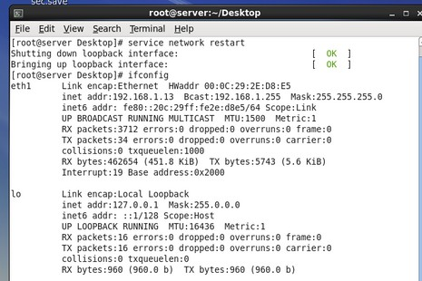

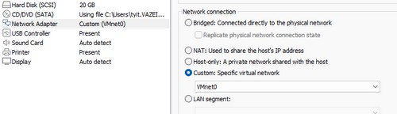

6) c. Setting Up a Mail Server

Rpm –qa | grep sendmail cd..

cd /etc/media/RHEL…/Packages ls sendmail*

rpm –ivh procmail…ctrl+d rpm –ivh sendmail…ctrl+d rpm –ivh sendmail.cf..ctrl+d

(we have to install all three files if it is not available )

|  |
| --- |
| rpm –qa | grep sendmail    cd ..  cd /etc/mail  gedit sendmail.mc (comment line 116) |

|  |
| --- |
| m4 /etc/mail/sendmail.mc > /etc/mail/sendmail.cf    service named start service sendmail start dig server.tyit.com    cd /root |

|  |
| --- |
| Now we will send the mail from root to tyit1  [root@server /]# mail tyit1 Subject : heiww  Body part.  Cntrl + D x2    Now , login to tyit1 Open cmd -> Type mail  the mail sent by the root user is shown here |

|  |
| --- |
| PRACTICAL 8 : Shell Scripts  8) a Writing shell scripts  1. Write a shell script that will accept directory name if the directory does not exist create a directory create 3 empty files in that directory. If the directory exist list the content of directory     1. Write a shell script for process management with the following menu:   List the name currently logged in users   * Check the group which the current user belongs to * View the active process * Find the info of process like (-pid,user,owner,pty,etc) |